**Pizza Sales Queries**

**Question 1:** Number of Rows in each table

```

SELECT COUNT(*) FROM orders;

```

**Output:**

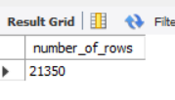

```

SELECT COUNT(*) FROM order_details; # 48620

```

**Output:**

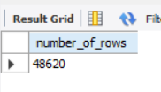

```

SELECT COUNT(*) FROM pizza_types; # 32

```

**Output:**

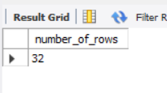

```

SELECT COUNT(*) FROM pizzas; # 96

```

**Output:**

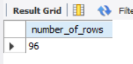

**Question 2:** What is the year of data present

```

SELECT DISTINCT YEAR(date)

FROM orders; # 2015

```

**Output**

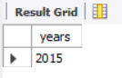

**Question 3:** Number of pizza sold per each category

```

SELECT pt.category, COUNT(*) AS number_of_pizza_sold

FROM order_details od

JOIN pizzas p

ON od.pizza_id=p.pizza_id

JOIN pizza_types pt

ON p.pizza_type_id=pt.pizza_type_id

GROUP BY pt.category;

```

**Output:**

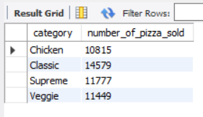

**Question 4:** Percentage of pizza sales per category

```

SELECT pt.category,

ROUND(SUM(od.quantity*p.price)*100/ (SELECT SUM(od.quantity*p.price)

FROM orders o

JOIN order_details od

ON o.order_id=od.order_id

JOIN pizzas p

ON od.pizza_id=p.pizza_id

-- WHERE MONTH(o.date) = 1 # if some filter is appliead outside subquery than it should also be present here for accurate results

), 4) AS percentage_of_sales_per_pizza

FROM orders o

JOIN order_details od

ON o.order_id=od.order_id

JOIN pizzas p

ON od.pizza_id=p.pizza_id

JOIN pizza_types pt

ON p.pizza_type_id=pt.pizza_type_id

-- WHERE MONTH(o.date) = 1 # To check for single month (currently checking for January)

GROUP BY pt.category;

```

**Output:**

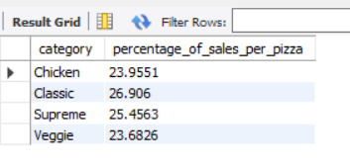

**Question 5:** Percentage of pizza sales per category

```

SELECT p.size,

ROUND(SUM(od.quantity*p.price)*100/ (SELECT SUM(od.quantity*p.price)

FROM orders o

JOIN order_details od

ON o.order_id=od.order_id

JOIN pizzas p

ON od.pizza_id=p.pizza_id

-- WHERE MONTH(o.date) = 1 # if some filter is appliead outside subquery than it should also be present here for accurate results

), 4) AS percentage_of_sales_per_pizza

FROM orders o

JOIN order_details od

ON o.order_id=od.order_id

JOIN pizzas p

ON od.pizza_id=p.pizza_id

JOIN pizza_types pt

ON p.pizza_type_id=pt.pizza_type_id

-- WHERE MONTH(o.date) = 1 # To check for single month (currently checking for January)

GROUP BY p.size;

```

**Output:**

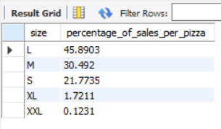

**Question 6:** Average Order Value

```

SELECT

SUM(p.price*od.quantity)/COUNT(DISTINCT od.order_id) AS Avg_Order_Value

FROM order_details od

JOIN pizzas p

ON od.pizza_id=p.pizza_id;

```

**Output:**

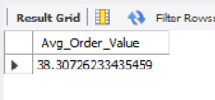

**Question 7:** Total pizza sold

```

SELECT SUM(quantity) AS total_pizza_sold

FROM order_details;

```

**Output:**

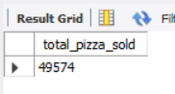

**Question 8:** Total order placed

```

SELECT

COUNT(DISTINCT order_id) AS total_order_placed

FROM order_details;

```

**Output:**

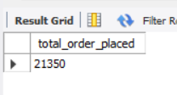

**Question 9:** Average pizza per order

```

SELECT

SUM(quantity)/COUNT(DISTINCT order_id) AS Average_pizza_per_order

FROM order_details;

```

**Output:**

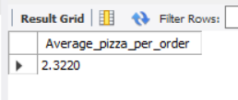

**Question 10:** Week wise total orders

```

SELECT

DAYNAME(date) AS weekdays,

COUNT(DISTINCT order_id) AS total_orders

FROM orders

GROUP BY weekdays;

```

**Output:**

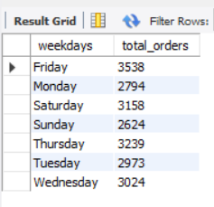

**Question 11:** What days and times do we tend to be busiest?

```

SELECT

DAY(o.date) AS busiest_day,

HOUR(o.time) AS busiest_hour,

COUNT(o.order_id) AS total_number_of_orders

FROM

orders o

JOIN

order_details od ON o.order_id = od.order_id

GROUP BY DAY(o.date) , HOUR(o.time)

ORDER BY total_number_of_orders DESC

LIMIT 1;

```

**Output:**

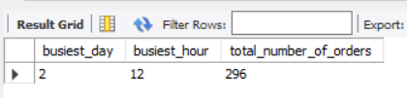

**Question 12:** How many customers do we have each day? Are there any peak hours?

```

SELECT DATE(o.date) AS date,

COUNT(*) AS number_of_customer_each_day,

COUNT(DISTINCT o.order_id) AS number_of_customers

FROM orders o

JOIN order_details od

ON o.order_id=od.order_id

GROUP BY DATE(o.date);

```

**Output:**

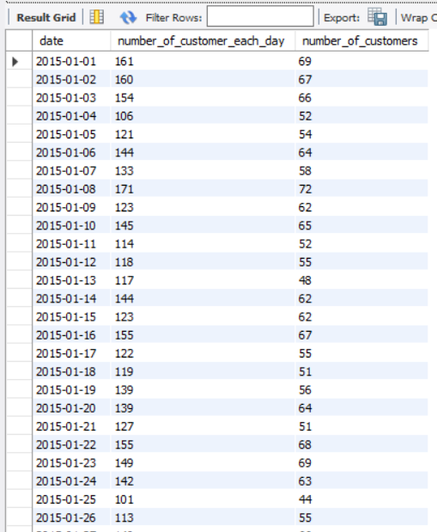

**Question 13:** How many pizzas are we making during peak periods?

```

WITH peak_hour AS (

SELECT HOUR(o.time) AS busiest_hour

FROM orders o

GROUP BY HOUR(o.time)

ORDER BY COUNT(o.order_id) DESC

LIMIT 1

)

SELECT COUNT(od.pizza_id) AS pizzas_at_peak_hour

FROM order_details od

JOIN orders o ON od.order_id = o.order_id

JOIN peak_hour ph ON HOUR(o.time) = ph.busiest_hour;

```

**Output:**

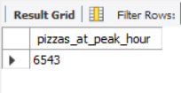

**Question 14:** How many pizzas are typically in an order? Do we have any bestsellers?

```

SELECT

order_id, MIN(quantity) AS pizzas_typically_in_an_order

FROM

order_details

GROUP BY order_id;

-- best seller

SELECT

p.pizza_id,

pt.name,

SUM(od.quantity * p.price) AS total_sales

FROM

order_details od

JOIN

pizzas p ON od.pizza_id = p.pizza_id

JOIN

pizza_types pt ON p.pizza_type_id = pt.pizza_type_id

GROUP BY p.pizza_id

ORDER BY total_sales DESC

LIMIT 1;

```

**Question 15:** What are top 5 Best selling pizzas

```

SELECT

pt.name,

ROUND(SUM(od.quantity*p.price), 4) AS total_sales

FROM

order_details od

JOIN

pizzas p ON od.pizza_id = p.pizza_id

JOIN

pizza_types pt ON p.pizza_type_id = pt.pizza_type_id

GROUP BY pt.name

ORDER BY total_sales DESC

LIMIT 5;

```

**Output:**

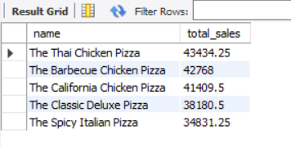

**Question 16:** What are the top 5 Worst selling pizzas

```

SELECT

pt.name,

ROUND(SUM(od.quantity*p.price), 4) AS total_revenue

FROM

order_details od

JOIN

pizzas p ON od.pizza_id = p.pizza_id

JOIN

pizza_types pt ON p.pizza_type_id = pt.pizza_type_id

GROUP BY pt.name

ORDER BY total_revenue ASC

LIMIT 5;

```

**Output:**

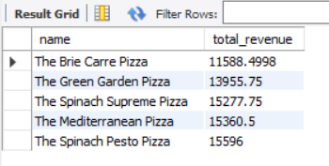

**Question 17:** Are there any pizzas we should take of the menu, or any promotions we could leverage?

```

SELECT

pt.name,

ROUND(SUM(od.quantity * p.price), 4) AS sales

FROM

order_details od

JOIN

pizzas p ON od.pizza_id = p.pizza_id

JOIN

pizza_types pt ON p.pizza_type_id = pt.pizza_type_id

GROUP BY pt.name

ORDER BY SUM(od.quantity * p.price) ASC

LIMIT 1;

```

**Output:**

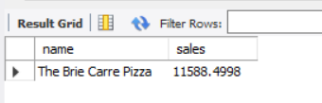

**Question 18:** What's our average order value?

```

SELECT

ROUND(AVG(order_total), 4) AS avg_order_value

FROM (

SELECT SUM(od.quantity * p.price) AS order_total

FROM order_details od

JOIN pizzas p ON od.pizza_id = p.pizza_id

GROUP BY od.order_id

) AS order_values;

```

**Output:**

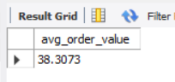

**Question 19**: How much money did we make this year? Can we indentify any seasonality in the sales?

```

SELECT

ROUND(SUM(od.quantity * p.price), 4) AS total_money_year

FROM

pizzas p

JOIN

order_details od ON p.pizza_id = od.pizza_id;

```

**Output:**

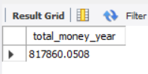

**Question 20: What are the Monthly number of orders?**

```

SELECT

MONTHNAME(date) AS month,

COUNT(DISTINCT order_id) AS total_orders

FROM orders

GROUP BY MONTH(date);

```

**Output:**

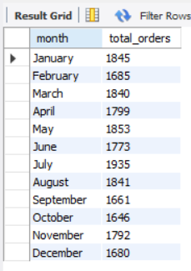

**Question 21:** What are Monthly sales?

```

SELECT

MONTHNAME(o.date) AS month,

ROUND(SUM(od.quantity * p.price), 2) AS total_sales

FROM

orders o

JOIN

order_details od ON o.order_id = od.order_id

JOIN

pizzas p ON od.pizza_id = p.pizza_id

GROUP BY

MONTH(o.date)

ORDER BY

MONTH(month);

```

**Output:**

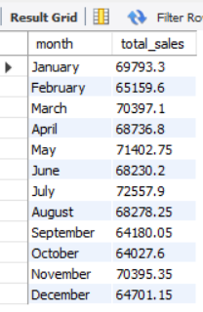

**Question 22:** What are Weekly orders?

```

SELECT

DAYNAME(date) AS weekday,

COUNT(DISTINCT order_id) AS total_orders

FROM orders

GROUP BY weekday;

```

**Output:**

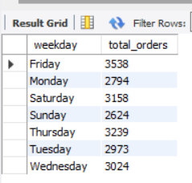

**Question 23:** What are Weekly sales?

```

SELECT

WEEK(o.date) AS week,

ROUND(SUM(od.quantity * p.price), 2) AS total_sales

FROM

orders o

JOIN

order_details od ON o.order_id = od.order_id

JOIN

pizzas p ON od.pizza_id = p.pizza_id

GROUP BY

WEEK(o.date)

ORDER BY

week;

```

**Output:**

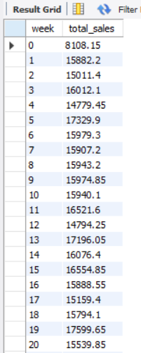

**Question 24:** What is Day of week order?

```

SELECT

DAY(date) AS day,

COUNT(DISTINCT order_id) AS total_orders

FROM orders

GROUP BY day;

```

**Output:**

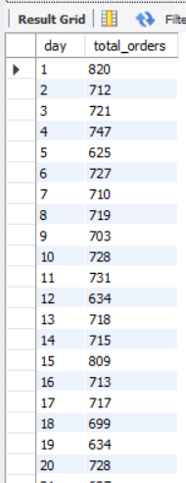

**Question 25:** What are Day of week sales

```

SELECT

DAYOFWEEK(o.date) AS day_of_week,

ROUND(SUM(od.quantity * p.price), 2) AS total_sales

FROM

orders o

JOIN

order_details od ON o.order_id = od.order_id

JOIN

pizzas p ON od.pizza_id = p.pizza_id

GROUP BY

DAYOFWEEK(o.date)

ORDER BY

total_sales DESC;

```

**Output:**

